## Settings

The **Settings** tab of the Messages screen provides information needed to configure a standard email client (such as Microsoft Outlook) to send and receive Direct messages. It also provides setup options for assigning delegates, enabling email notifications, and including a Direct message signature.

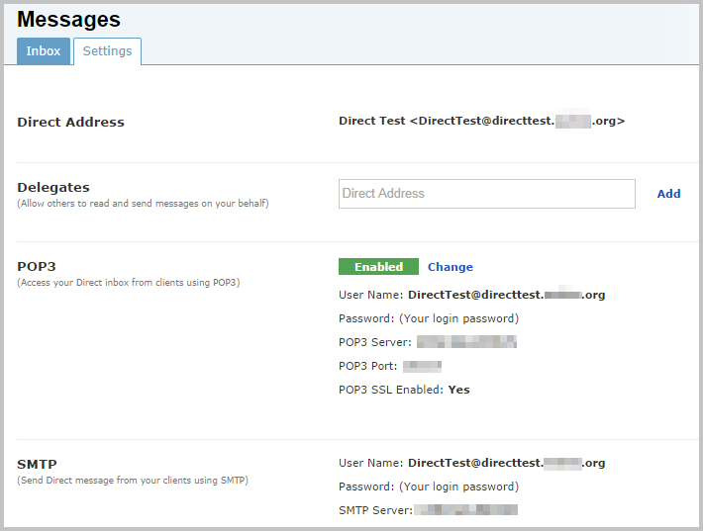

### Delegates

To grant an HIE user the ability to read and write Direct messages on your behalf, enter the Direct address of that user in the **Direct Address** field of the *Delegates* section.

If the delegate user’s address is part of the current user’s Direct domain, it will automatically be added to the list of delegates. If the address is not part of the current user’s Direct domain, click the **Add** link. If the Direct address can be verified, it will be added; otherwise, an error message will appear.

Multiple users can be added as delegates. To remove any previously added Direct addresses, click the red **X** at the end of the delegate’s row.

For more info on using delegates, see the “Delegates” section.

### Configuring Outlook and Other Email Clients

The information needed to set up a connection to another mail client (including your Direct address, POP3 settings, and STMP settings) are all available on the **Settings** screen.

To enable transactions through a POP3 server, make sure that the green *Enabled* notification is visible.

To disable POP3 transactions, click on the **Change** link in the *POP3* section. The green *Enabled* notification will change to a red *Disabled* notification.

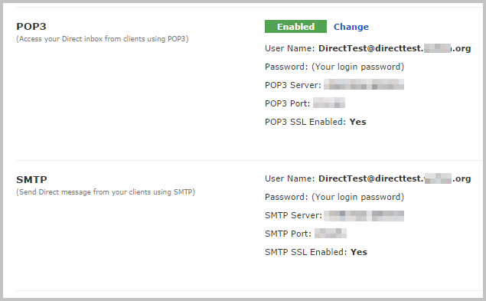

Note: Remember to use your HIE username and password when configuring access through the outside client.

**Notifications**

The Direct messaging system can be set to send notification emails to an external address when a Direct message is sent to you in the HIE system.

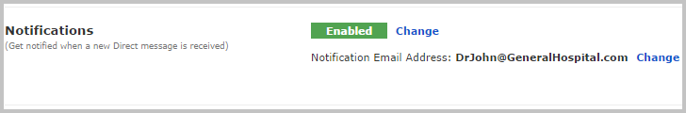

Note: Until the *Notifications* section is completed, notifications are not active and will not be sent.

To enable notifications, make sure that the green *Enabled* notification is visible. Then click on the **Change** link next to the *Notification Email Address:* header. Fill in a valid email address in the text box which appears.

To disable notifications, click on the **Change** link in the *POP3* section. The green *Enabled* notification will change to a red *Disabled* notification.

**Creating a Signature**

If desired, you may automatically append a signature to your Direct Messages. For example, a signature might include information your name, your contact information, and a statement about information disclosure policy.

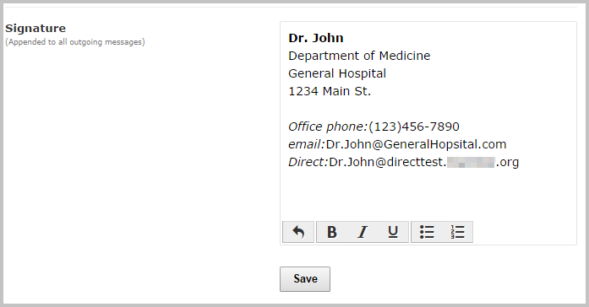

Enter your desired text in the *Signature* window. Basic text formatting options are available in the toolbar at the bottom of the window. Once done, click **Save.** Any text included will appear automatically at the end of each Direct message you compose.